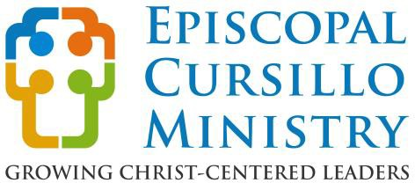
A Movement
A Method
A Ministry

What is Cursillo? • An opportunity to grow in faith and in spirituality • A deeper understanding of the teachings of Jesus and how we can serve Him. • An experience of living and sharing with others in a loving and caring Christian community and realizing that this can be extended into our own environment • A continuing community that gives support and encouragement to help Christians carry out their Baptismal Vows.
The Episcopal Cursillo Weekend: Cursillo offers a time to experience living in a supportive Christian community though the Episcopal Cursillo Weekend. Across the country and the world, dioceses offer weekends following a three-day schedule that begins on Thursday evening and concludes on Sunday. The weekend includes fifteen talks, five meditations and a Eucharist every day. The Episcopal Cursillo Weekend isn’t a retreat. It’s an opportunity to gather with clergy and laity, seeking to strengthen our faith. It provides an environment to experience the reality of God’s gift of love through shared prayer, individual meditation, worship, study, fellowship, laughter, tears, and unconditional love.
The key elements of the Episcopal Cursillo Ministry are
relationship, evangelism, and reconciliation
in the home, the parish, the community, and the world.

After the Weekend: Each person returning from a weekend is encouraged to actively participate in what Cursillo calls “Fourth Day,” which extends for the rest of their lives. Through the Cursillo community, there are ongoing opportunities to support Christian living and ministry.
What’s expected of participants? • To be open and willing to respond to what you experience, to share your feelings with others, and allow them to share theirs with you. • To make a genuine effort to discover where you are and where or how you can grow in your Christian life. • To feel secure in the knowledge that you are accepted where you are and as you are, and to know that any specific responses are not expected of you.
Contact:
Your parish priest
Council Chair: Kaye Curtis
Christ Church, Greenville
kayecurtis@gmail.com

Spiritual Director: Scotty Brock+
St. David’s, Columbia
sbrock@stdavidscolumbia.org

Registrar: Janet Jendron
St Paul’s, Fort Mill
jjendronjanet@gmail.com
- https://www.edusc.org/cursillo/
EDUSC Cursillo Weekends:
Gravatt Camp and Conference Center 1006 Camp Gravatt Road, Aiken SC 29805
Weekend 146 is Feb 1-4, 2024
Weekend 147 is Octobe 3-6, 2024

