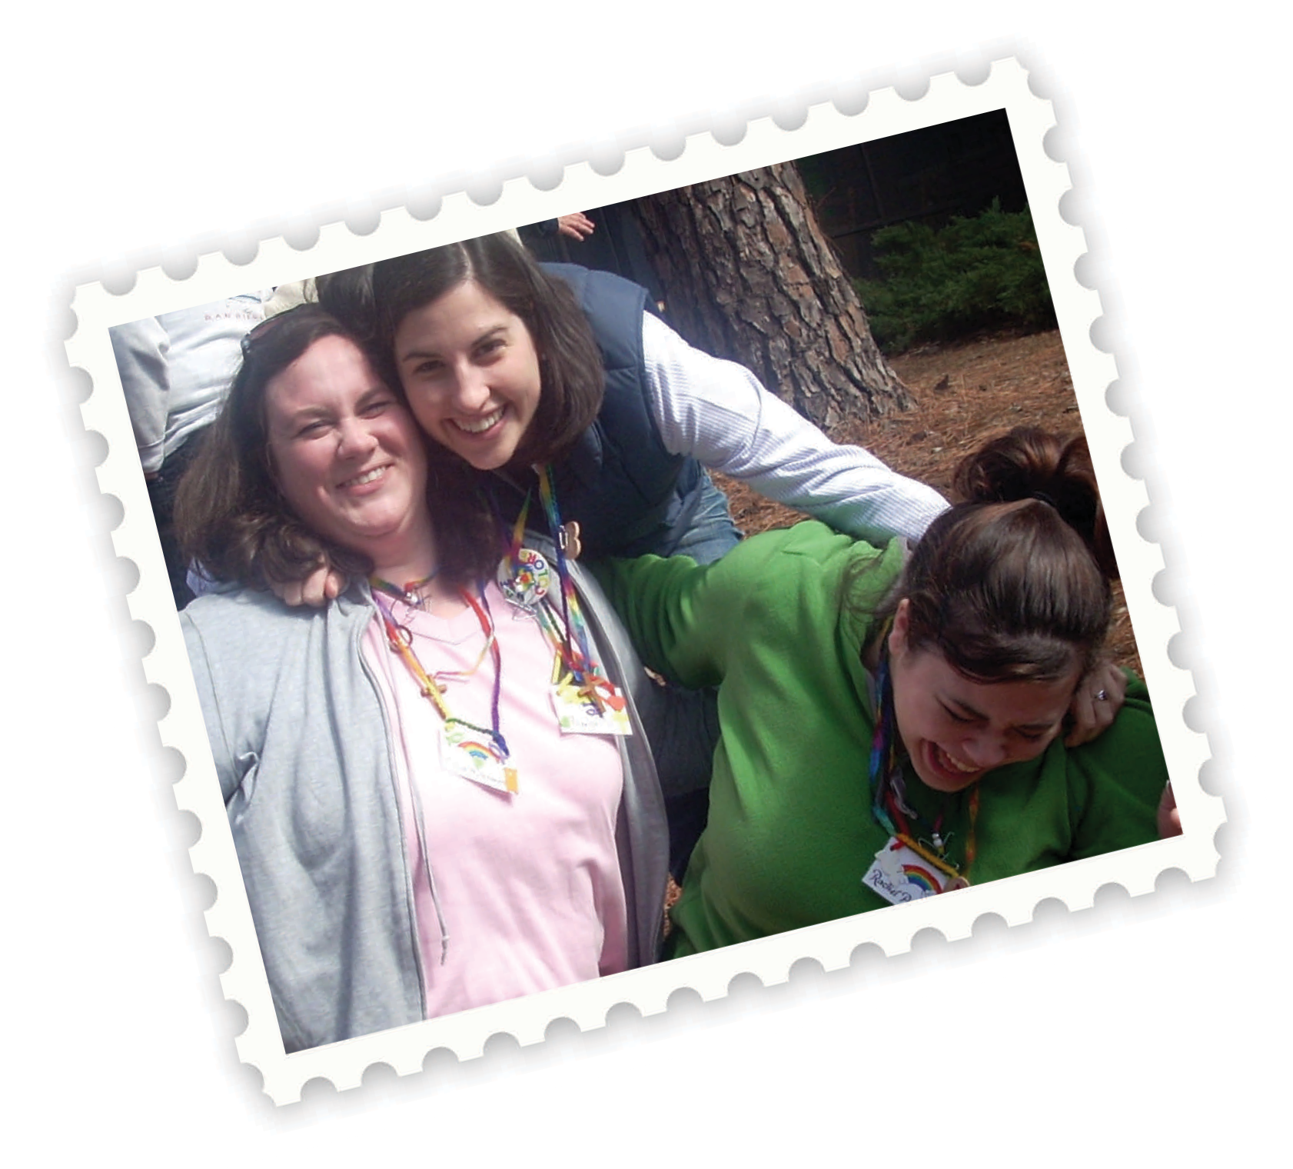
What is the goal for Cursillo?

The goal of Cursillo is the goal of the Church: to bring all to Christ. This is done when informed, trained leaders set out with the support of others having a similar commitment.

What is Cursillo
Cursillo is a movement of the church. It is also a method to help those of us in the church understand our individual callings to be Christian Leaders. Cursillo provides tools that help us bring Christ into our many environments ‐ family, work,
social life, and at church. Cursillo emphasizes servant leadership within these settings.

Growing Christ Centered Leaders

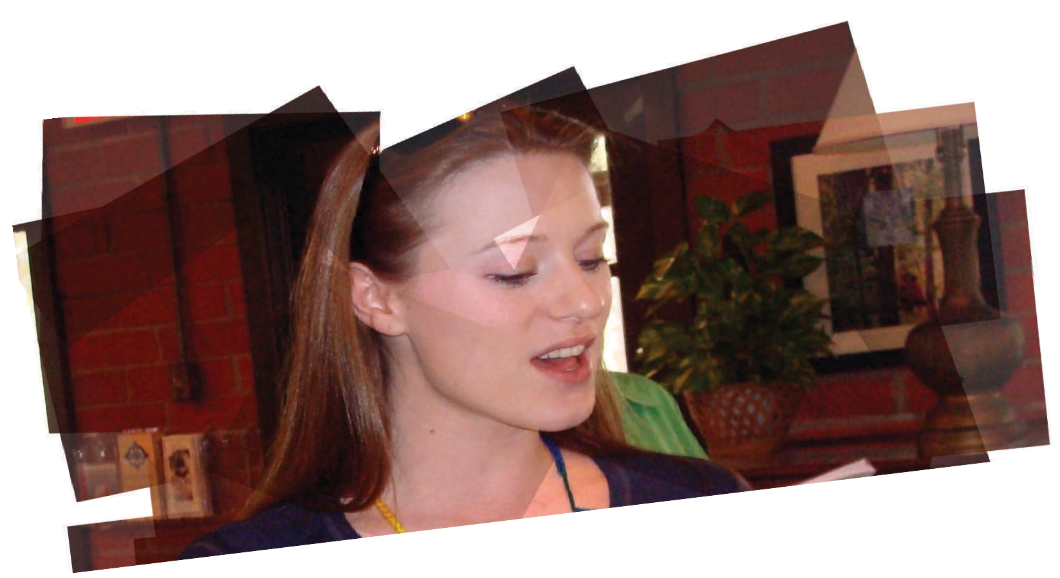
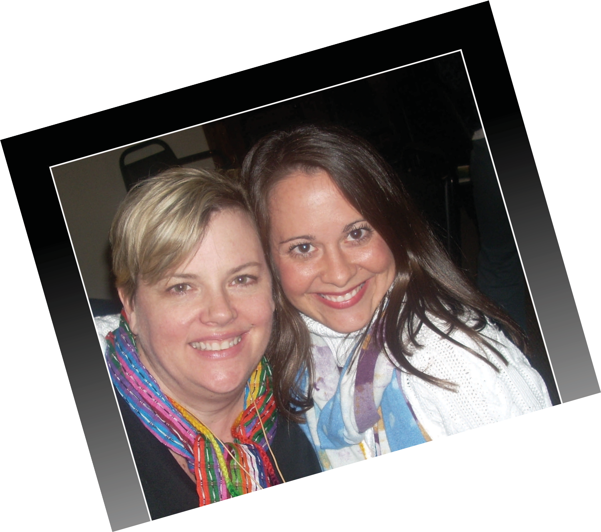
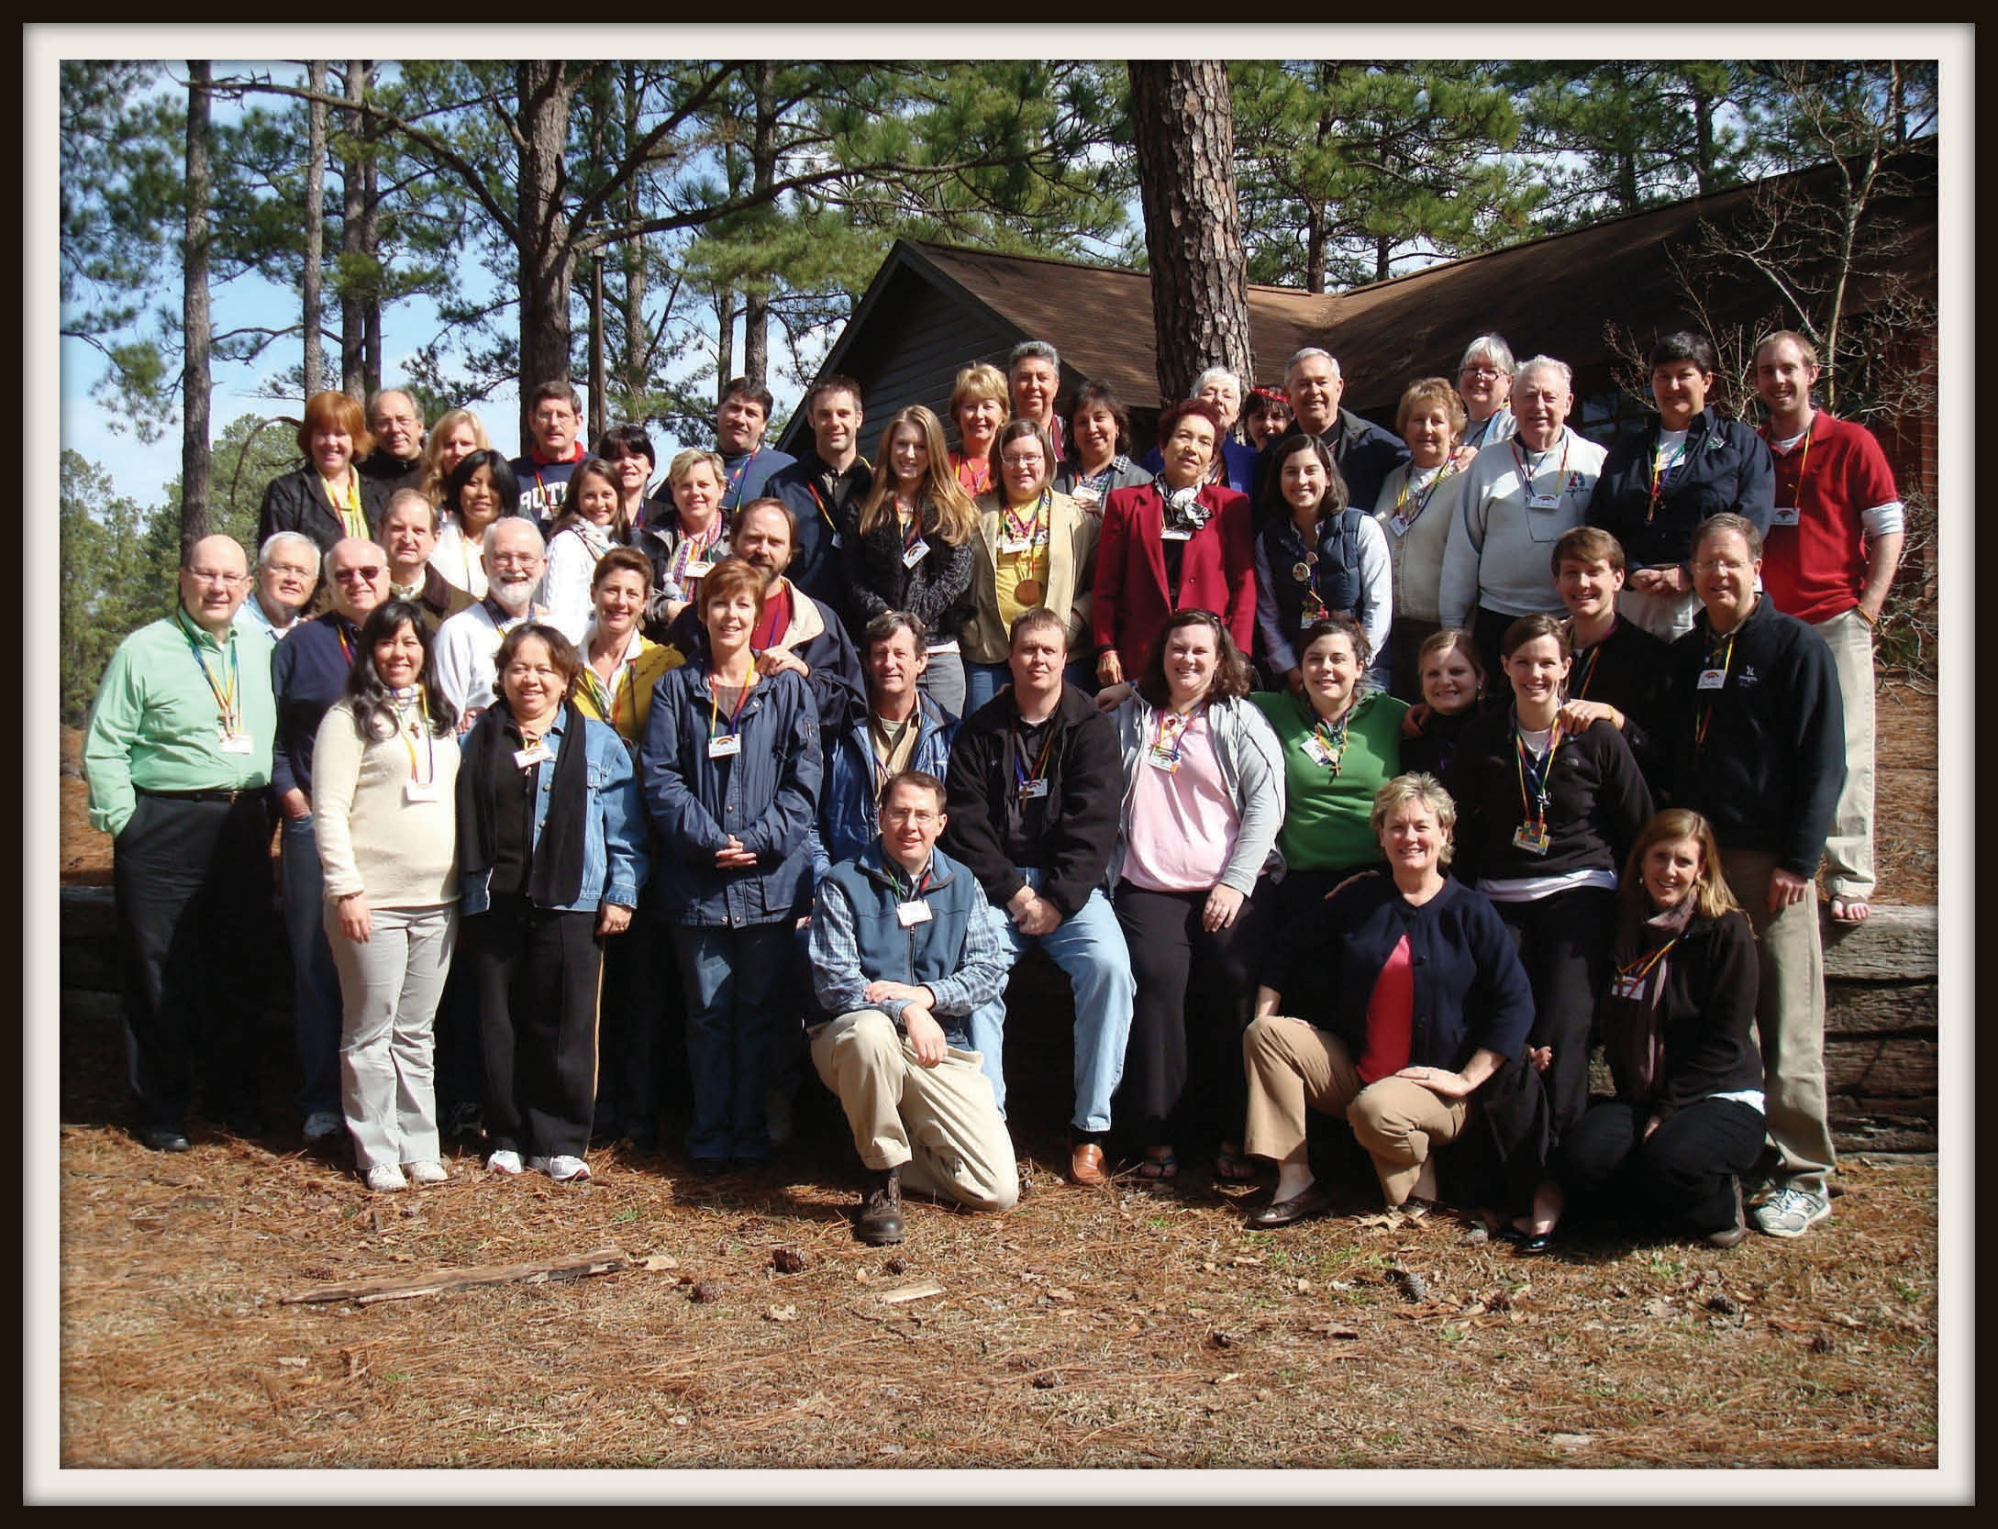
What does Cursillo do?
It helps to renew and deepen Christian commitment. Cursillo is one of many renewal movements. Many people have said Cursillo provides an important learning experience which causes many to feel like newly made Christians with a purpose and with support.

real relationships real people

real life
…But grace was given to each of us according to the meas‐ ure of Christ's gift. And His gifts were that some should be apostles, some prophets, some evangelists, some pastors and teachers, to equip the saints for the work

Ephesians 4:7, 11-12
The Three Day Weekend
Brings together a diverse groups to share the richness of many modes of worship and to broaden each one's appreciation for our Church. Lay people conduct the weekend with two or three members of the clergy as spiritual advisors. Cursillo presumes that those who attend are already well grounded in the faith. It is not intended to be a conversion experience but an enriching and deepening of what is already there. It often provides new insights into our faith as well as fostering ministry among lay people. The weekend begins Thursday evening spent in the Chapel with meditations, discussions, and Compline. After breakfast on Friday participants are assigned to table groups for the weekend. The three days are filled with talks and group discussions with emphasis on the doctrine of Grace, the Sacraments, and the great Cursillo tripod: Piety, Study, and Action.

Piety Study Action

More Information
Check out our website:

www.edusc.org/Cursillo

