LEARN MORE!

www.edusc.org/Cursillo/

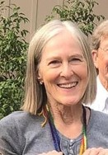
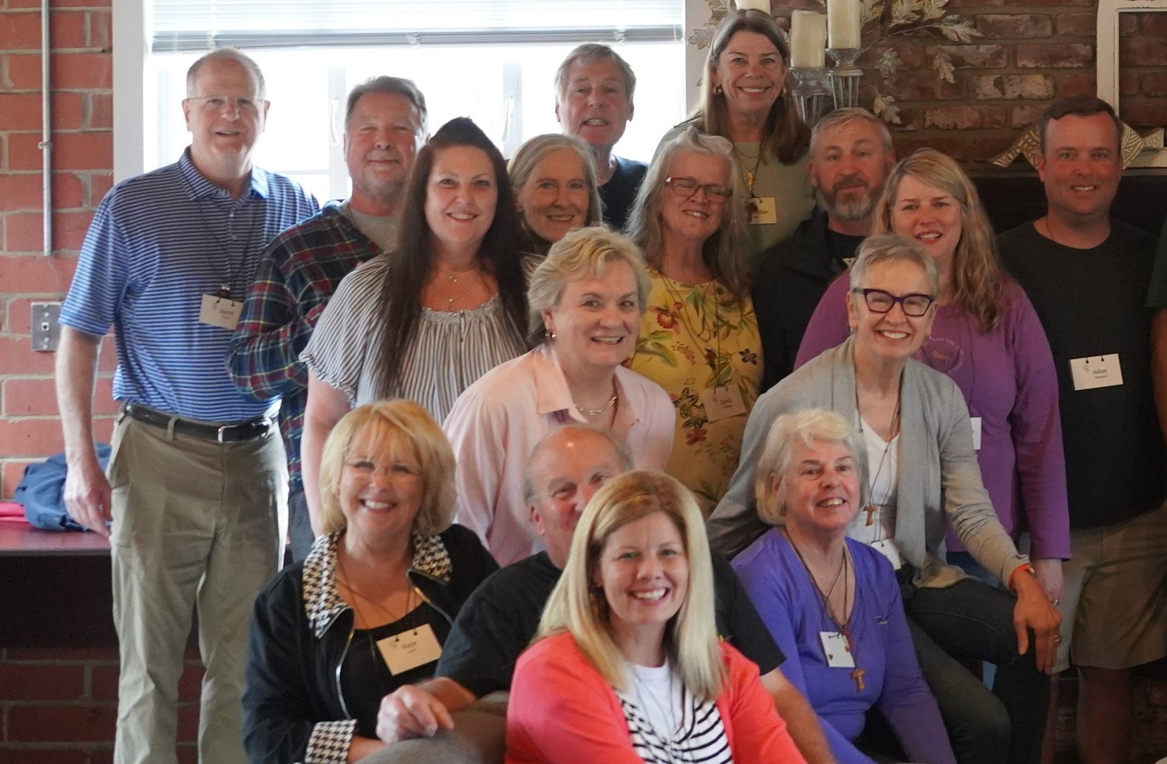

A ministry of the Episcopal Diocese
of Upper South Carolina
"I was fortunate to attend Cursillo in Alabama 39 years ago when I was 30. I loved God and loved church, which provided the "what" of a Christian life, but my Cursillo weekend gave me the "how" tools I needed to live a balanced life of faith.

For more than thirty years, I met weekly with my group reunion, and we held each other accountable to a life of piety (worship), study (learning about the gift of God), and action (being God's hands and feet in the world). We also learned how to talk about God (evangelize) in a very natural way, as "God-talk" became a weekly practice.

My long-ago Cursillo weekend was far more than a retreat -- it was my roadmap for a faith-full life."

Sharon Landis, Cursillo Participant
www.episcopalcursilloministry.org

UPCOMING DATES

October 3-6, 2024

March 27-30, 2025

A "SHORT COURSE,"

WHAT IS
CURSILLO?
The literal translation of the Spanish

CURSILLO PROVIDES:
An environment to experience the reality of God's gift of love through

STEP 1
EASY STEPS TO APPLY FOR CURSILLO:

word "Cursillo" is a short course.

OFFERED OVER A 3-DAY WEEKEND,
Beginning on Thursday evening and concluding on Sunday afternoon, the Cursillo weekend includes 15 short talks or courses, 5 meditations, and daily worship and music led by lay volunteers.

AWAY FROM EVERY DAY DISTRACTIONS.
Located in Aiken, SC, The Bishop Gravatt Center hosts the Cursillo weekend in a rustic, retreat environment. Casual attire is best!
shared prayer, individual meditation, worship, study, fellowship, laughter, tears, and unconditional love
An opportunity to grow in faith and in spirituality
Experience with a method involving piety, study, and action to deepen our spiritual journey

CURSILLO MANTRA:
"All may, some should, none must."

CURSILLO #143
Inform your clergy that you are interested in attending an upcoming Cursillo. They will help you find a sponsor (someone who has previously attended Cursillo, who will guide you through the Cursillo experience, before and after the weekend.)

STEP 2
Have a conversation with the prospective sponsor and ensure that they are able to sponsor you.

STEP 3
Begin an application (found at www.edusc.org/Cursillo/ or use QR Code on the opposite side of this brochure) that your sponsor will also need to help you complete and submit.

