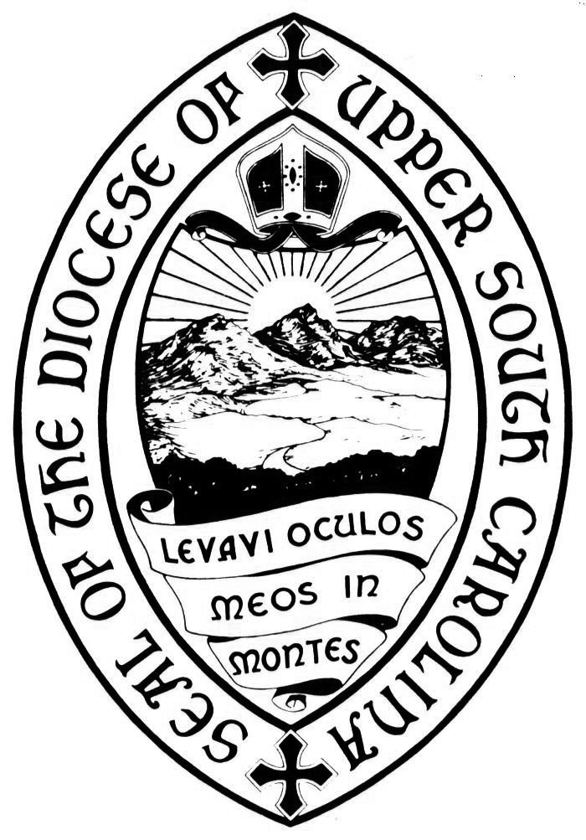
PROPOSED AMENDMENT TO THE CANONS OR CHANGE TO CONSTITUTION

The 97th Convention of the Diocese of Upper South Carolina
Christ Church

Greenville, South Carolina

November 8-9, 2019

Please return completed forms on or before September 9, 2019
(per the Canons, forms must be received no later than 60 days prior to Convention to be considered)

Completed forms may be submitted via:
Fax: 803-799-5119
Email (completed, scanned forms): convention@edusc.org OR
Mail: Regina Ratterree, Secretary to Convention, 1115 Marion Street, Columbia, SC 29201.

Date: ___________________________

Offered by __________________________________________________________

Name of Church ______________________________ City ___________________

Title ___________
Canon ___________or (Section) ______________ of Canon ______________)

is Hereby Amended So As To Read As Follows (attach additional page if necessary):

